**SCHOOL OF COMPUTER SCIENCE AND ENGINEERING**

Fall Semester, 2020-21

CSE1007 – Java Programming Lab

Digital Assingment-1

Roll Number: 19BCE0758

Name: R Narayan

1. Basic Programs Date – 15/07/2020
2. Read the radius and print the area of a circle

Code:

//*19BCE0758*

//*R Narayan*

import *java*.*util*.*Scanner*;

*public* *class* Circle

{

*public* *static* void *main*(String[] args)

    {

        int r;

        double pi = 3.14, area;

        Scanner s = *new* *Scanner*(System.*in*);

        System.*out*.*print*("Enter radius of circle:");

        r = s.*nextInt*();

        area = pi * r * r;

        System.*out*.*println*("Area of circle:"+area);

    }

}

Output:

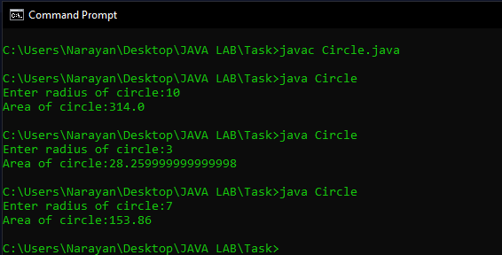

1. Read the number and check whether it is divisible by 3 and 5.

Code:

//*19BCE0758*

//*R Narayan*

import *java*.*util*.*Scanner*;

*class* Divisibility{

*public* *static* void *main*(String [] args)

    {

        System.*out*.*println*("Enter a number");

        Scanner s = *new* *Scanner*(System.*in*);

        int a;

        a = s.*nextInt*();

*if*(a%15 == 0){

            System.*out*.*println*("yes divisible by 3 and 5\n");

        }

*else*{

            System.*out*.*println*("not divisible by 3 and 5\n");

        }

    }

}

Output:

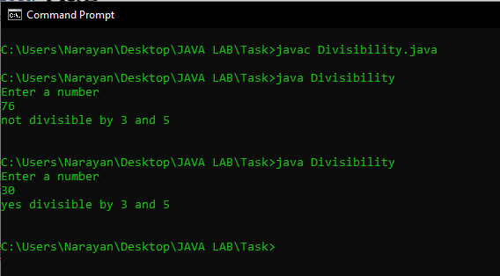

1. Display Subject Name based on room number. If the user enters 604 then display Java Programming , If the user enters 605 then display Python programming for any other input display Invalid input to the user

Code:

//*19BCE0758*

//*R Narayan*

import *java*.*util*.*Scanner*;

*class* Labroom{

*public* *static* void *main*(String [] args){

        System.*out*.*println*("Enter the lab No");

        Scanner s = *new* *Scanner*(System.*in*);

        int a;

        a = s.*nextInt*();

*if*(a == 604){

            System.*out*.*println*("Java Programming Lab");

        }

*else* *if*(a == 605){

            System.*out*.*println*("Python programming lab");

        }

*else*{

            System.*out*.*println*("Invalid Input");

        }

    }

}

Output:

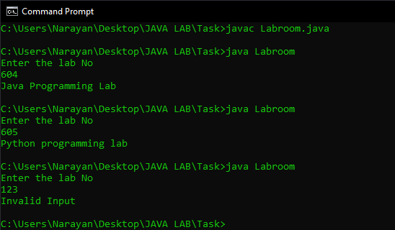

1. Print the sum of first n numbers. If n is 3 then print the sum of 1+2+3 to the user. Get n from the user

Code:

//*19BCE0758*

//*R Narayan*

import *java*.*util*.*Scanner*;

*class* Series1{

*public* *static* void *main*(String [] args){

        System.*out*.*println*("Enter a No");

        Scanner s = *new* *Scanner*(System.*in*);

        int a,sum=0;

        a = s.*nextInt*();

*for*(int i = 1; i<a+1;i++){

            sum = sum + i;

        }

        System.*out*.*print*("Sum is ");

        System.*out*.*println*(sum);

    }

}

Output:

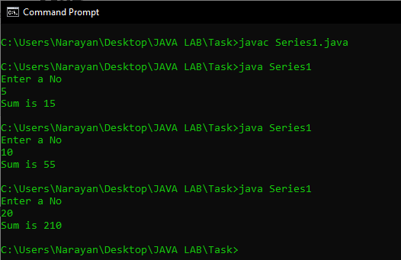

1. Print the sum of the series 12+22+32 up to n terms

Code:

//*19BCE0758*

//*R Narayan*

import *java*.*util*.*Scanner*;

*class* Series2{

*public* *static* void *main*(String [] args){

        System.*out*.*println*("Enter a No");

        Scanner s = *new* *Scanner*(System.*in*);

        int a,sum=0;

        a = s.*nextInt*();

*for*(int i = 1; i<a+1;i++){

            sum = sum + i*i;

        }

        System.*out*.*print*("Sum is ");

        System.*out*.*println*(sum);

    }

}

Output:

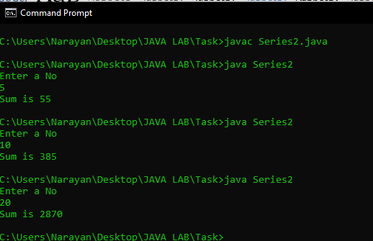

1. Print the multiplication table by getting the n from the user.

Code:

//*19BCE0758*

//*R Narayan*

import *java*.*util*.*Scanner*;

*class* Mtable{

*public* *static* void *main*(String [] args)

    {

        System.*out*.*println*("Enter the number");

        Scanner s = *new* *Scanner*(System.*in*);

        int a;

        a = s.*nextInt*();

*for*(int i = 1; i<11; i++){

            System.*out*.*print*(i);

            System.*out*.*print*(" X ");

            System.*out*.*print*(a);

            System.*out*.*print*(" = ");

            System.*out*.*println*(a*i);

        }

    }

}

Output:

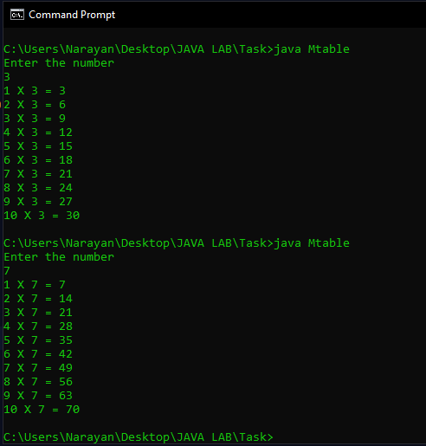

1. Provide the option of adding two numbers to the user until the user wants to exit.

Code:

//*19BCE0758*

//*R Narayan*

import *java*.*util*.*Scanner*;

*class* Calc{

*public* *static* void *main*(String [] args){

        Scanner s = *new* *Scanner*(System.*in*);

        int a = 0;

*do*{

            System.*out*.*println*("\n\t\tMenu\n\t1.add\n\t2.exit\n\tSelect an option");

            a = s.*nextInt*();

*if*(a == 1){

                int n1,n2;

                System.*out*.*println*("Enter First No");

                n1 = s.*nextInt*();

                System.*out*.*println*("Enter Second No");

                n2 = s.*nextInt*();

                System.*out*.*println*("Sum is ");

                System.*out*.*println*(n1+n2);

            }

*else* *if*(a != 2){

                System.*out*.*println*("Invalid Input");

            }

        }*while*(a != 2);

    }

}

Output:

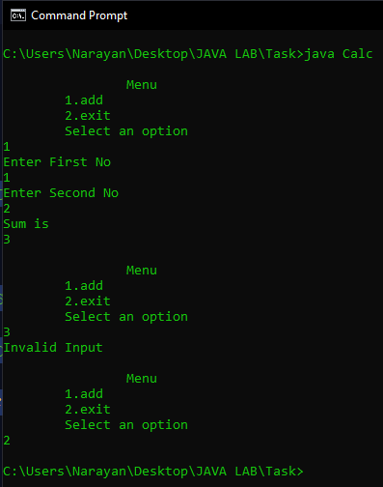

1. Print this pattern for n lines

Code:

//*19BCE0758*

//*R Narayan*

import *java*.*util*.*Scanner*;

*class* Patterns  {

*public* *static* void *main*(String [] args){

        Scanner s = *new* *Scanner*(System.*in*);

        int a = 0;

*do*{

            System.*out*.*println*("\n\t\tMenu\n1.Pattern a\n2.Pattern b\n3.Pattern c\n4.Exit\nSelect an option\n");

            a = s.*nextInt*();

*if*(a == 1){

                int n;

                System.*out*.*println*("Enter n");

                n = s.*nextInt*();

*for*(int i = 1;i < n+1;i++){

*for*(int j = 0; j < i; j++){

                        System.*out*.*print*("*");

                    }

                    System.*out*.*print*('\n');

                }

            }

*else* *if*(a == 2){

                System.*out*.*println*("Enter n");

                int n;

                n = s.*nextInt*();

*for*(int i = n; i>0; i--){

*for*(int j = 1; j<i+1; j++){

                        System.*out*.*print*(j);

                    }

                    System.*out*.*print*('\n');

                }

            }

*else* *if*(a == 3){

                System.*out*.*println*("Enter n");

                int n;

                n = s.*nextInt*();

*for*(int i = 1; i<n+1; i++){

*for*(int j = 1; j<i+1; j++){

                        System.*out*.*print*(j);

                    }

                    System.*out*.*print*('\n');

                }

*for*(int i = n; i>0; i--){

*for*(int j = 1; j<i+1; j++){

                        System.*out*.*print*(j);

                    }

                    System.*out*.*print*('\n');

                }

            }

*else* *if*(a != 4){

                System.*out*.*println*("Invalid Choice");

            }

        }*while*(a != 4);

    }

}

Output:

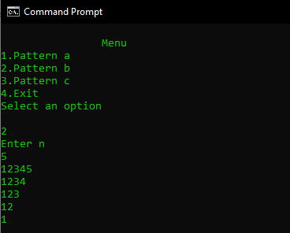

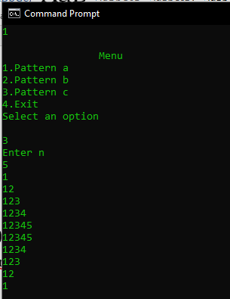

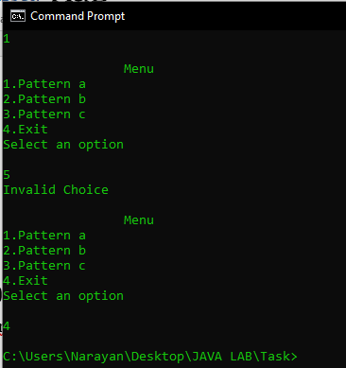

1. Lab 1 Date - 22/07/2020
2. Write a java Program to display the sum of rows in a matrix

Code:

import *java*.*util*.*Scanner*;

*public* *class* Rowm {

*public* *static* void *main*(String[] args) {

        int r, c, sumRow = 0;

        Scanner s = *new* *Scanner*(System.*in*);

        System.*out*.*println*("Enter the rows and columns:");

        r = s.*nextInt*();

        c = s.*nextInt*();

        int a[][] = *new* int[r][c];

        System.*out*.*println*("Enter the matrix");

*for* (int i = 0; i < r; i++) {

*for* (int j = 0; j < c; j++) {

                a[i][j] = s.*nextInt*();

            }

        }

*for* (int i = 0; i < r; i++) {

            sumRow = 0;

*for* (int j = 0; j < c; j++) {

                sumRow = sumRow + a[i][j];

            }

            System.*out*.*println*("Sum of " + (i + 1) + " row: " + sumRow);

        }

    }

}

Output:

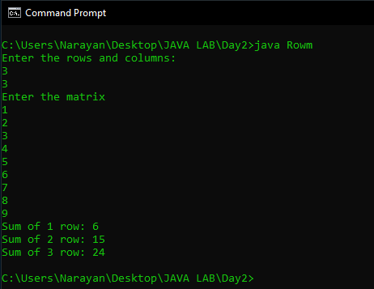

1. Write a java Program to display the addition of two matrix

Code:

import *java*.*util*.*Scanner*;

*public* *class* Addmatrix {

*public* *static* void *main*(String[] args) {

        int r, c;

        Scanner s = *new* *Scanner*(System.*in*);

        System.*out*.*println*("Enter the rows and columns:");

        r = s.*nextInt*();

        c = s.*nextInt*();

        int a[][] = *new* int[r][c];

        int b[][] = *new* int[r][c];

        int sum[][] = *new* int[r][c];

        System.*out*.*println*("Enter the first matrix");

*for* (int i = 0; i < r; i++) {

*for* (int j = 0; j < c; j++) {

                a[i][j] = s.*nextInt*();

            }

        }

        System.*out*.*println*("Enter the second matrix");

*for* (int i = 0; i < r; i++) {

*for* (int j = 0; j < c; j++) {

                b[i][j] = s.*nextInt*();

            }

        }

*for* (int i = 0; i < r; i++) {

*for* (int j = 0; j < c; j++) {

                sum[i][j] = b[i][j] + a[i][j];

            }

        }

        System.*out*.*println*("Sum of the 2 matrices");

*for* (int i = 0; i < r; i++) {

*for* (int j = 0; j < c; j++) {

                System.*out*.*print*(sum[i][j] + " ");

            }

            System.*out*.*print*("\n");

        }

    }

}

Output:

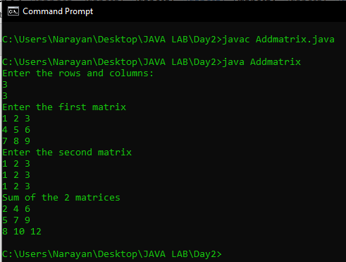

1. Write a java Program to display the transpose of a matrix

Code:

import *java*.*util*.*Scanner*;

*public* *class* Transpose {

*public* *static* void *main*(String[] args) {

        int r, c;

        Scanner s = *new* *Scanner*(System.*in*);

        System.*out*.*println*("Enter the rows and columns:");

        r = s.*nextInt*();

        c = s.*nextInt*();

        int a[][] = *new* int[r][c];

        System.*out*.*println*("Enter the matrix");

*for* (int i = 0; i < r; i++) {

*for* (int j = 0; j < c; j++) {

                a[i][j] = s.*nextInt*();

            }

        }

        System.*out*.*println*("transpose matrix");

*for* (int i = 0; i < r; i++) {

*for* (int j = 0; j < c; j++) {

                System.*out*.*print*(a[j][i] + " ");

            }

            System.*out*.*println*(" ");

        }

    }

}

Output:

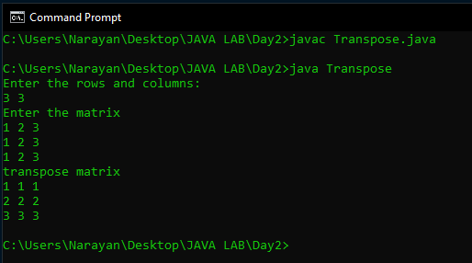

1. Write a Java program to sort an array of positive integers of an given array, in the sorted array the value of the first element should be maximum, second value should be minimum value, third should be second maximum, fourth second be second minimum and so on.

Code:

//*19BCE0758*

//*R Narayan*

import *java*.*util*.*Scanner*;

*class* MaxMin {

*public* *static* void *main*(String[] args) {

        int n;

        Scanner s = *new* *Scanner*(System.*in*);

        System.*out*.*println*("Input the length of the array");

        n = s.*nextInt*();

        System.*out*.*println*("Enter the array");

        int arr[] = *new* int[n];

*for* (int i = 0; i < n; i++) {

            arr[i] = s.*nextInt*();

        }

        int temp[] = *new* int[n];

        int small = 0, large = n - 1;

        boolean flag = true;

*for* (int i = 0; i < n; i++) {

*for* (int j = i; j < n - i - 1; j++) {

*if* (arr[j] > arr[j + 1]) {

                    int t = arr[j];

                    arr[j] = arr[j + 1];

                    arr[j + 1] = t;

                }

            }

        }

*for* (int i = 0; i < n; i++) {

*if* (flag)

                temp[i] = arr[large--];

*else*

                temp[i] = arr[small++];

            flag = !flag;

        }

        System.*out*.*println*("Modified Array ");

*for* (int i = 0; i < n; i++) {

            System.*out*.*print*(temp[i] + " ");

        }

    }

}

Output:

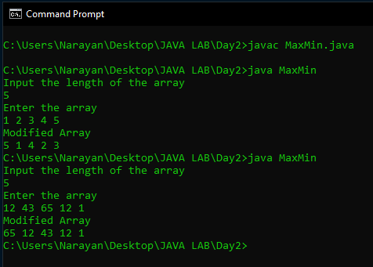

1. Write a Java program to separate even and odd numbers of an given array of integers. Put all even numbers first, and then odd numbers.

Code:

import *java*.*util*.*Scanner*;

*class* Rearrange {

*public* *static* void *main*(String[] args) {

        Scanner s = *new* *Scanner*(System.*in*);

        System.*out*.*println*("Enter the number of elements");

        int n = s.*nextInt*();

        int l = 0, r = n - 1;

        int arr[] = *new* int[n];

        int temp[] = *new* int[n];

        System.*out*.*println*("Enter the array");

*for* (int i = 0; i < n; i++) {

            arr[i] = s.*nextInt*();

        }

*for* (int i = 0; i < n; i++) {

*if* (arr[i] % 2 == 0) {

                temp[l] = arr[i];

                l = l + 1;

            } *else* {

                temp[r] = arr[i];

                r = r - 1;

            }

        }

*for* (int i = 0; i < r; i++) {

            System.*out*.*println*(temp[i]);

        }

    }

}

Output:

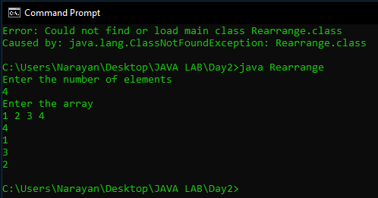

1. Write a Java program to remove the duplicate elements of a given array and return the new length of the array.

Code:

//*19BCE0758*

//*R Narayan*

import *java*.*util*.*Scanner*;

*public* *class* RemDupli {

*public* *static* void *main*(String[] args) {

        Scanner s = *new* *Scanner*(System.*in*);

        int n;

        System.*out*.*println*("Enter the length of the array");

        n = s.*nextInt*();

        int j = 0;

        int arr[] = *new* int[n];

        System.*out*.*println*("Enter the array");

*for* (int i = 0; i < n; i++) {

            arr[i] = s.*nextInt*();

        }

*if* (n != 0 && n != 1) {

            int[] temp = *new* int[n];

*for* (int i = 0; i < n - 1; i++) {

*if* (arr[i] != arr[i + 1]) {

                    temp[j++] = arr[i];

                }

            }

            temp[j++] = arr[n - 1];

*for* (int i = 0; i < j; i++) {

                arr[i] = temp[i];

            }

        }

        System.*out*.*println*("The New array is of length " + j);

*for* (int i = 0; i < j; i++)

            System.*out*.*print*(arr[i] + " ");

    }

}

Output:

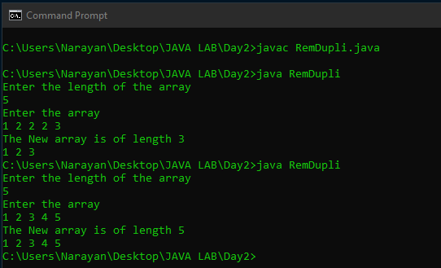

1. Write a Java program to find the sum of the two elements of a given array which is equal to a given integer.

Code:

//*19BCE0758*

//*R Narayan*

import *java*.*util*.*Scanner*;

*public* *class* SumMatch {

*public* *static* void *main*(String[] args) {

        Scanner s = *new* *Scanner*(System.*in*);

        System.*out*.*println*("Enter the length of the array");

        int n = s.*nextInt*();

        int arr[] = *new* int[n];

        System.*out*.*println*("Enter the matrix");

*for* (int i = 0; i < n; i++) {

            arr[i] = s.*nextInt*();

        }

        System.*out*.*println*("Enter the sum ");

        int sum = s.*nextInt*();

        int flag = 0;

*for* (int i = 0; i < n; i++) {

*for* (int j = i + 1; j < n; j++) {

*if* (arr[i] + arr[j] == sum) {

                    flag = 1;

                    System.*out*.*println*(arr[i] + " + " + arr[j] + " = " + sum);

                }

            }

        }

*if* (flag == 0) {

            System.*out*.*println*("No Pairs found");

        }

    }

}

Output:

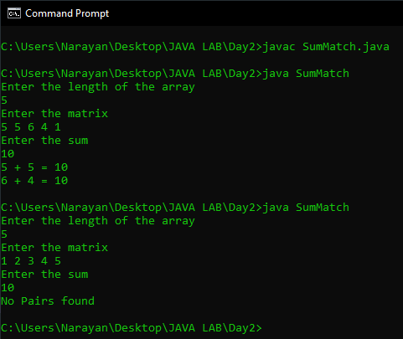

1. Write a program to demonstrate the knowledge of students in multidimensional arrays and looping constructs. Eg., If there are 4 batches in BTech - “CSE1007” course, read the count of the slow learners (who have scored <25) in each batch. Tutors should be assigned in the ratio of 1:4 (For every 4 slow learners, there should be one tutor). Determine the number of tutors for each batch. Create a 2-D jagged array with 4 rows to store the count of slow learners in the 4 batches. The number of columns in each row should be equal to the number of groups formed for that particular batch ( Eg., If there are 23 slow learners in a batch, then there should be 6 tutors and in the jagged array, the corresponding row should store 4, 4, 4, 4, 4,3). Use for-each loop to traverse the array and print the details. Also print the number of batches in which all tutors have exactly 4 students.

Code:

//*19BCE0758*

//*R Narayan*

import *java*.*util*.*Scanner*;

*class* SlowLearners {

*public* *static* void *main*(String arr[]) {

        Scanner s = *new* *Scanner*(System.*in*);

        int no, tut, nbatch;

        System.*out*.*println*("Enter the number of batches");

        nbatch = s.*nextInt*();

        int tot = 0;

        int a[][] = *new* int[nbatch][];

*for* (int i = 0; i < nbatch; i++) {

            System.*out*.*println*("Enter the number of slow learners in batch " + i);

            no = s.*nextInt*();

*if* (no % 4 == 0)

                tut = no / 4;

*else*

                tut = no / 4 + 1;

            a[i] = *new* int[tut];

*for* (int j = 0; j < tut; j++) {

*if* (no > 4) {

                    a[i][j] = 4;

                    no = no - 4;

                } *else* {

                    a[i][j] = no;

                    no = 0;

                }

            }

        }

        System.*out*.*println*("\n\nThe Contents of Jagged array are");

*for* (int i = 0; i < nbatch; i++) {

*for* (int n *:* a[i]) {

                System.*out*.*print*(n + " ");

*if* (n == 4)

                    tot++;

            }

            System.*out*.*println*();

        }

        System.*out*.*println*("\n\nThe number of Tutors with 4 students are = " + tot);

    }

}

Output:

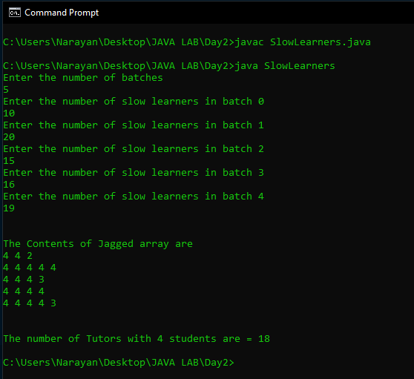

1. Lab-2 Date – 29/07/2020
2. Write a java Program to check whether given string is palindrome or not.

Code:

//*19BCE0758*

//*R Narayan*

import *java*.*util*.*Scanner*;

*class* CheckPalindrome {

*public* *static* void *main*(String args[]) {

        String str;

        Scanner sc = *new* *Scanner*(System.*in*);

        System.*out*.*println*("Enter a string:");

        str = sc.*nextLine*();

        int n = str.*length*();

        int flag = 1;

*for* (int i = n - 1; i >= 0; i--) {

*if* (str.*charAt*(i) != str.*charAt*(n - i - 1)) {

                flag = 0;

            }

        }

*if* (flag == 0) {

            System.*out*.*println*("Not a Palindrome");

        } *else* {

            System.*out*.*println*("Palindrome");

        }

    }

}

Output:

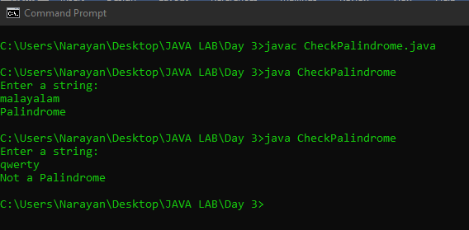

1. Write a java program to sort the names in descending order

Code:

//*19BCE0758*

//*R Narayan*

import *java*.*util*.*Scanner*;

*public* *class* SortNames {

*public* *static* void *main*(String[] args) {

        int n;

        String temp;

        Scanner s = *new* *Scanner*(System.*in*);

        System.*out*.*print*("Enter number of names you want to enter:");

        n = s.*nextInt*();

        String names[] = *new* String[n];

        Scanner s1 = *new* *Scanner*(System.*in*);

        System.*out*.*println*("Enter all the names:");

*for* (int i = 0; i < n; i++) {

            names[i] = s1.*nextLine*();

        }

*for* (int i = 0; i < n; i++) {

*for* (int j = i + 1; j < n; j++) {

*if* (names[i].*compareTo*(names[j]) < 0) {

                    temp = names[i];

                    names[i] = names[j];

                    names[j] = temp;

                }

            }

        }

        System.*out*.*println*("Sorted Names");

*for* (int i = 0; i < n - 1; i++) {

            System.*out*.*println*(names[i]);

        }

        System.*out*.*print*(names[n - 1]);

    }

}

Output:

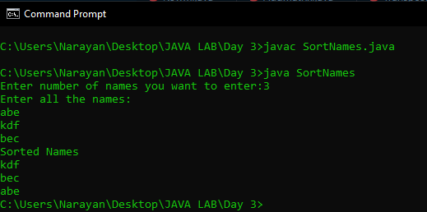

1. Write a Java program to sort a string array in ascending order.

Input the string : hello world welcome to vit

Expected Output :cdeeehillllmoooorttvww

Code:

//*19BCE0758*

//*R Narayan*

import *java*.*util*.*Scanner*;

*class* SortString {

*public* *static* void *main*(String args[]) {

        String str;

        Scanner sc = *new* *Scanner*(System.*in*);

        System.*out*.*println*("Enter a string:");

        str = sc.*nextLine*();

        int n = str.*length*();

        char[] ar = str.*toCharArray*();

*for* (int i = 0; i < n - 1; i++) {

*for* (int j = 0; j < n - i - 1; j++) {

*if* ((int) ar[j] > (int) ar[j + 1]) {

                    char temp = ar[j];

                    ar[j] = ar[j + 1];

                    ar[j + 1] = temp;

                }

            }

        }

        System.*out*.*println*("String in Ascending order");

*for* (int i = 0; i < n; i++) {

*if* (ar[i] != ' ') {

                System.*out*.*print*(ar[i]);

            }

        }

    }

}

Output:

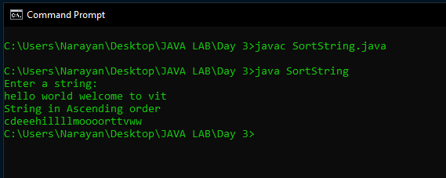

1. Write a java Program to check whether the given two strings are anagram or not.

Code:

//*19BCE0758*

//*R Narayan*

import *java*.*util*.*Scanner*;

*class* CheckAnagram {

*public* *static* void *main*(String args[]) {

        String str1, str2;

        Scanner sc = *new* *Scanner*(System.*in*);

        System.*out*.*println*("Enter a string:");

        str1 = sc.*nextLine*();

        System.*out*.*println*("Enter Second String");

        str2 = sc.*nextLine*();

        int n1 = str1.*length*();

        int n2 = str2.*length*();

*if* (n1 == n2) {

            int flag = 1;

            char[] ar1 = str1.*toCharArray*();

            char[] ar2 = str2.*toCharArray*();

*for* (int i = 0; i < n1 - 1; i++) {

*for* (int j = 0; j < n1 - i - 1; j++) {

*if* ((int) ar1[j] < (int) ar1[j + 1]) {

                        char temp = ar1[j];

                        ar1[j] = ar1[j + 1];

                        ar1[j + 1] = temp;

                    }

*if* ((int) ar2[j] < (int) ar2[j + 1]) {

                        char temp = ar2[j];

                        ar2[j] = ar2[j + 1];

                        ar2[j + 1] = temp;

                    }

                }

            }

*for* (int i = 0; i < n1; i++) {

*if* (ar1[i] != ar2[i]) {

                    flag = 0;

                }

            }

*if* (flag == 1) {

                System.*out*.*println*("Anagrams");

            } *else* {

                System.*out*.*println*("Not Anagram");

            }

        } *else* {

            System.*out*.*println*("Not Anagram");

        }

    }

}

Output:

